5. (25p) Answer all the questions on an electronic document.

A radar uses a Barker 7 (B-7) sequence having the following characteristics:

• chip pulse width: τc=1 μs (sequence length: 7 μs);

• samples per chip: N=40;

• B-7 magnitude: A=1 V

The signal is reflected back to the radar by a target moving with a radial velocity of 4000 km/h:

1. Make a plot of the real and imaginary components of the signal coming back to the radar (that is, the signal before the matched filter) when the SNR is 20 dB. Consider that the operating frequency of the radar is 2.8 GHz.

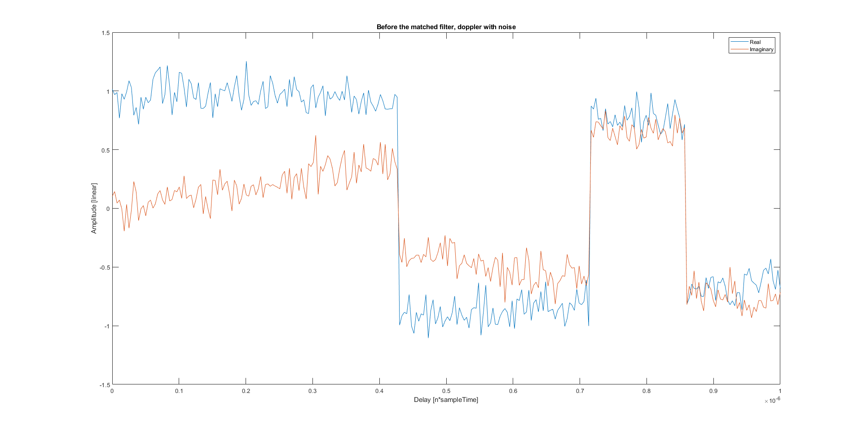

Figure 1. Before the matched filter barker 7 separated imaginary and real

1. Make a plot of the magnitude, in linear scale, of the signal at the output of the matched filter. Make some comments about the output signal.

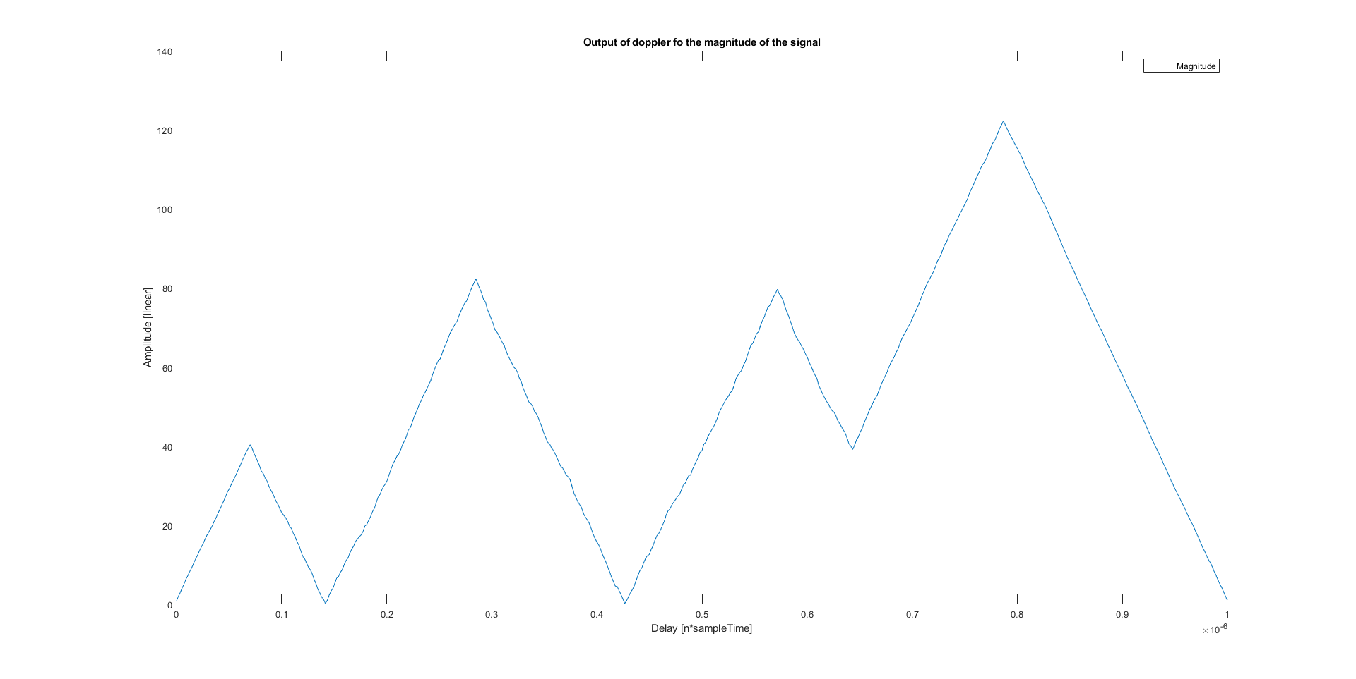

As we know, radars have low doppler tolerance and are quite sensitive. At first glance the signal seems like it isn’t anything like the original correlated signal. But there is correlation just that the signal has been delayed.